Incident Response Report
Case ID: SOC326
Analyst | Ahmed Emad Nasr
Date | September 17, 2024
Severity | Medium
Verdict | True Positive

--------------------------------------------------
1. Executive Summary
--------------------------------------------------
On September 17, 2024, at 12:05 PM, the SOC generated a Medium severity alert related to a suspicious MX record change for a typosquatted domain: letsdefwnd.io, impersonating the legitimate domain letsdefend.io.

Further investigation confirmed this activity as part of a targeted phishing campaign. The attacker successfully delivered a phishing email into the corporate environment, and an internal user (Hostname: Mateo) interacted with the malicious link.

Endpoint telemetry confirmed that the user accessed the phishing website and established an outbound connection to an attacker-controlled IP address.

Final Assessment: True Positive
Risk Level: Critical (Confirmed User Interaction & Potential Credential Compromise)
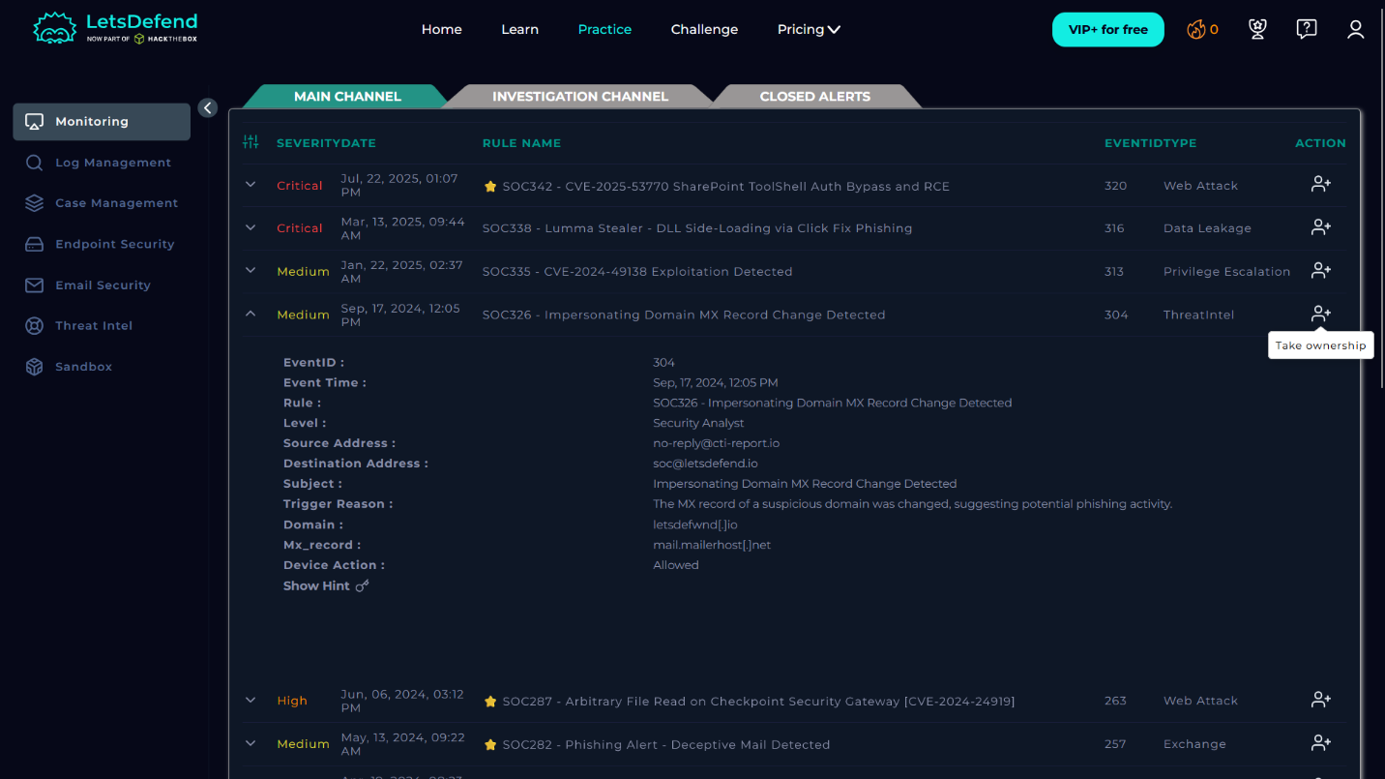

--------------------------------------------------
2. Initial Alert Details
--------------------------------------------------

[General Information]
Rule Name: SOC326 - Impersonating Domain MX Record Change Detected
Event ID: 304
Timestamp: September 17, 2024 – 12:05 PM
Initial Severity: Medium
Event Type: ThreatIntel
Trigger Reason: Suspicious MX record change on potential phishing domain
Device Action: Allowed

[Domain Information]
Malicious Domain: letsdefwnd.io
MX Record: mail.mailerhost.net
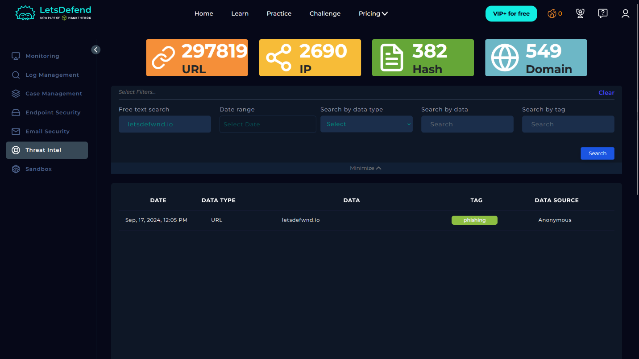
--------------------------------------------------
3. Indicators of Compromise (IoCs)
--------------------------------------------------

[Attacker Infrastructure]
Domain:
- letsdefwnd.io
- http://www.letsdefwnd.io/

Attacker IP:
- 45.33.23.183

Attacker Email:
- voucher@letsdefwnd.io

[Internal Assets]
Compromised Endpoint IP:
- 172.16.17.162

Hostname:
- Mateo

Mail Server:
- 172.16.20.3
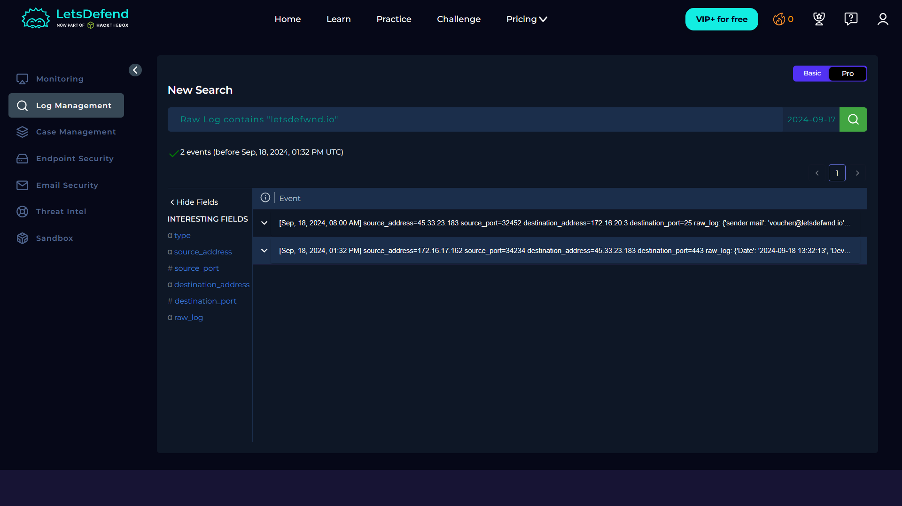

--------------------------------------------------
4. Attack Lifecycle Analysis (Cyber Kill Chain)
--------------------------------------------------

[Phase 1: Weaponization / Infrastructure Setup]
- Domain letsdefwnd.io registered as typosquatted domain
- MX record configured (mail.mailerhost.net)
- Threat Intel classification: Phishing

Conclusion:
Attacker prepared infrastructure for phishing campaign.

--------------------------------------------------

[Phase 2: Delivery]
- Inbound SMTP connection observed
- Source IP: 45.33.23.183
- Source Port: 32452
- Destination IP: 172.16.20.3 (Exchange Server)
- Destination Port: 25 (SMTP)

Email Details:
Sender: voucher@letsdefwnd.io

Conclusion:
Phishing email successfully delivered into internal environment.

--------------------------------------------------

[Phase 3: User Interaction]
- Endpoint: Mateo (172.16.17.162)
- Timestamp: September 18, 2024 – 01:32 PM

Browser Activity:
Visited URL:
http://www.letsdefwnd.io/

Conclusion:
User clicked phishing link → confirmed interaction.

--------------------------------------------------

[Phase 4: Actions on Objectives]
- Outbound connection initiated from endpoint
- Source IP: 172.16.17.162
- Destination IP: 45.33.23.183
- Destination Port: 443 (HTTPS)

Conclusion:
- Encrypted communication established
- Possible:
* Credential harvesting
* Malware delivery
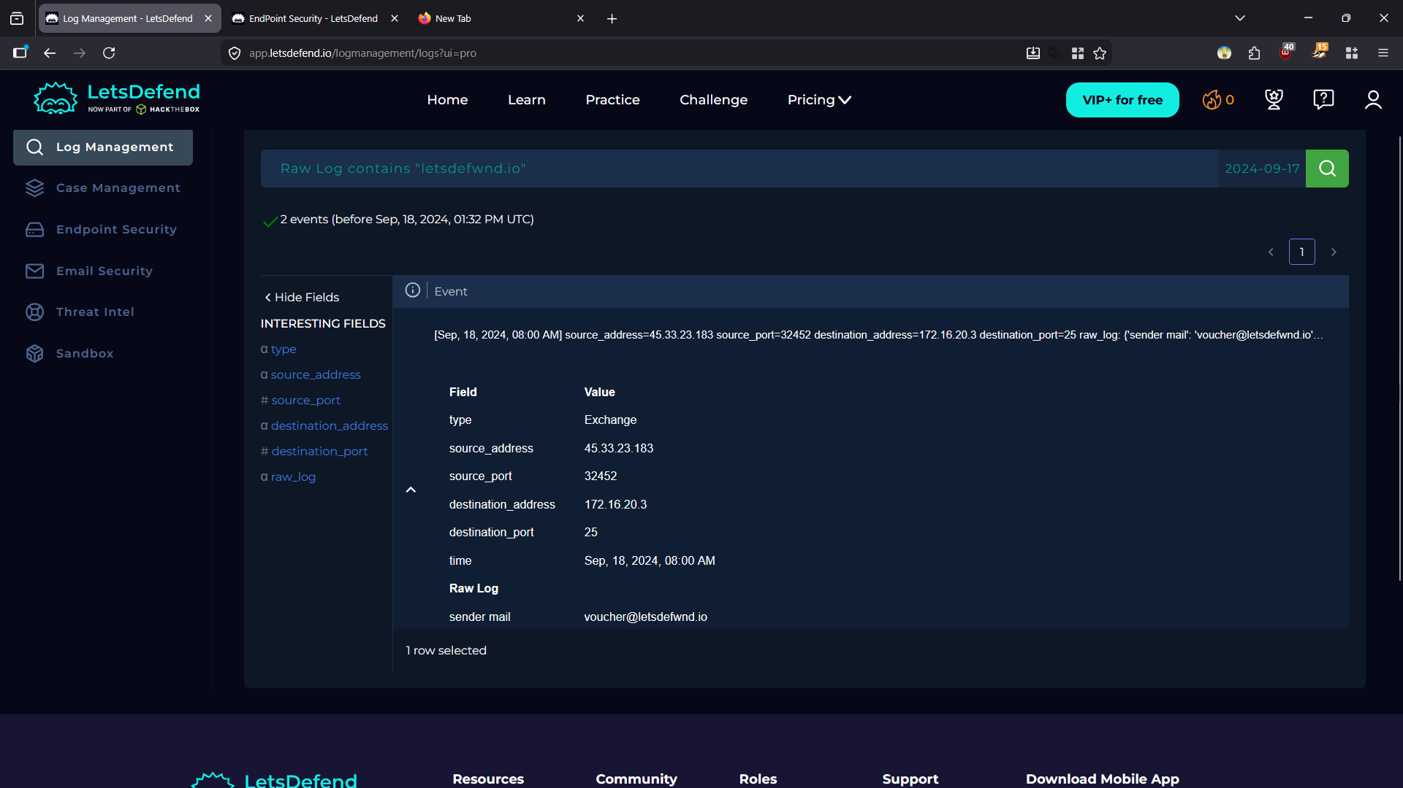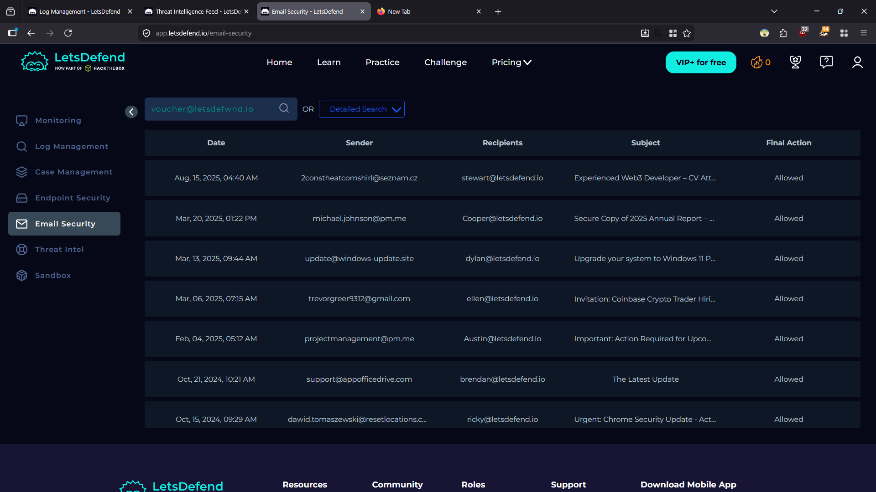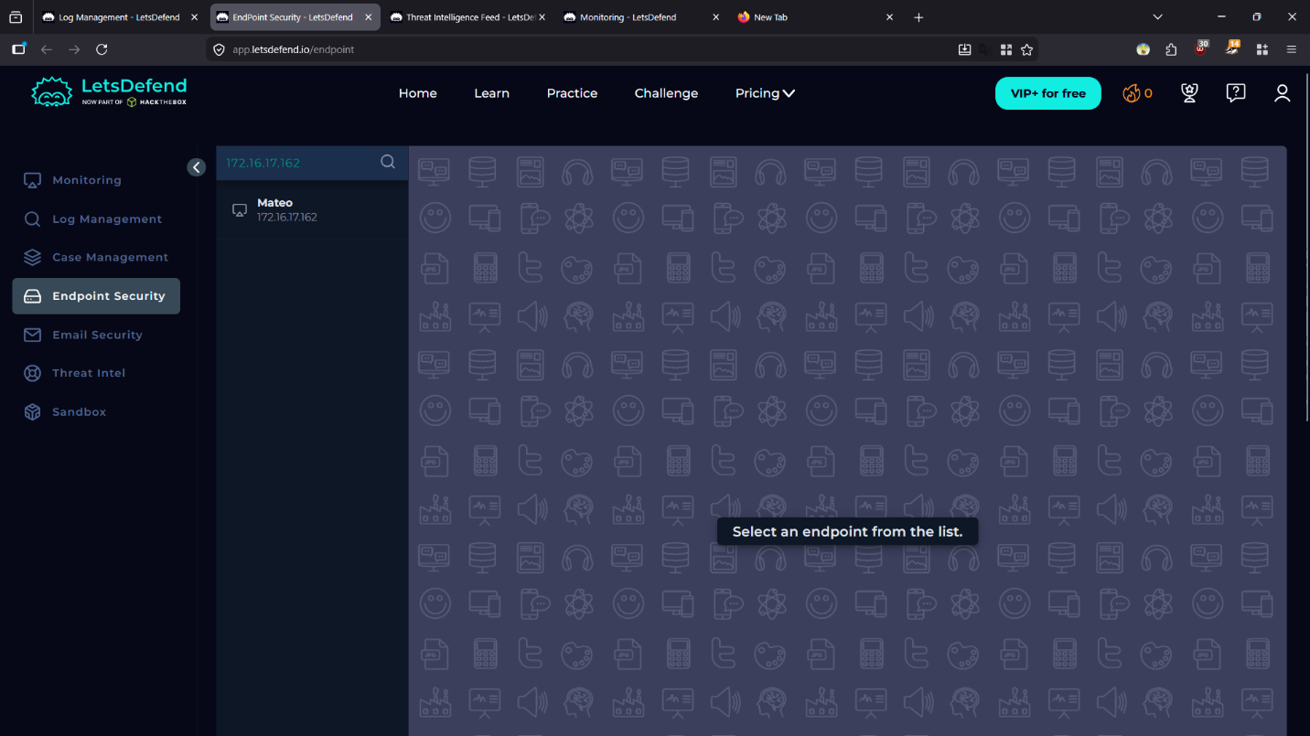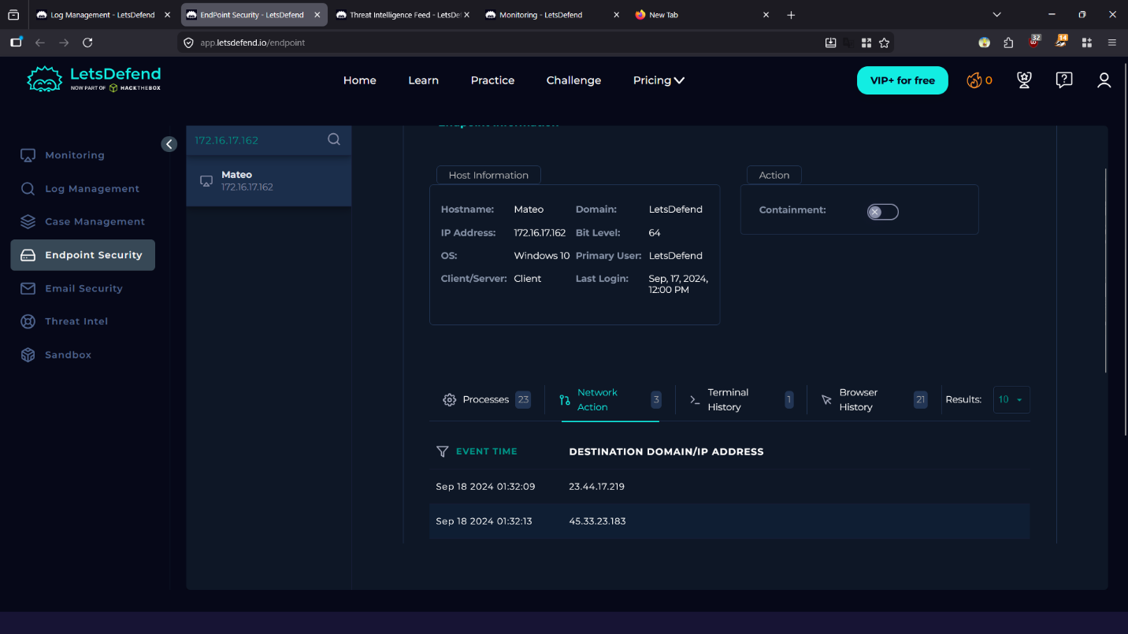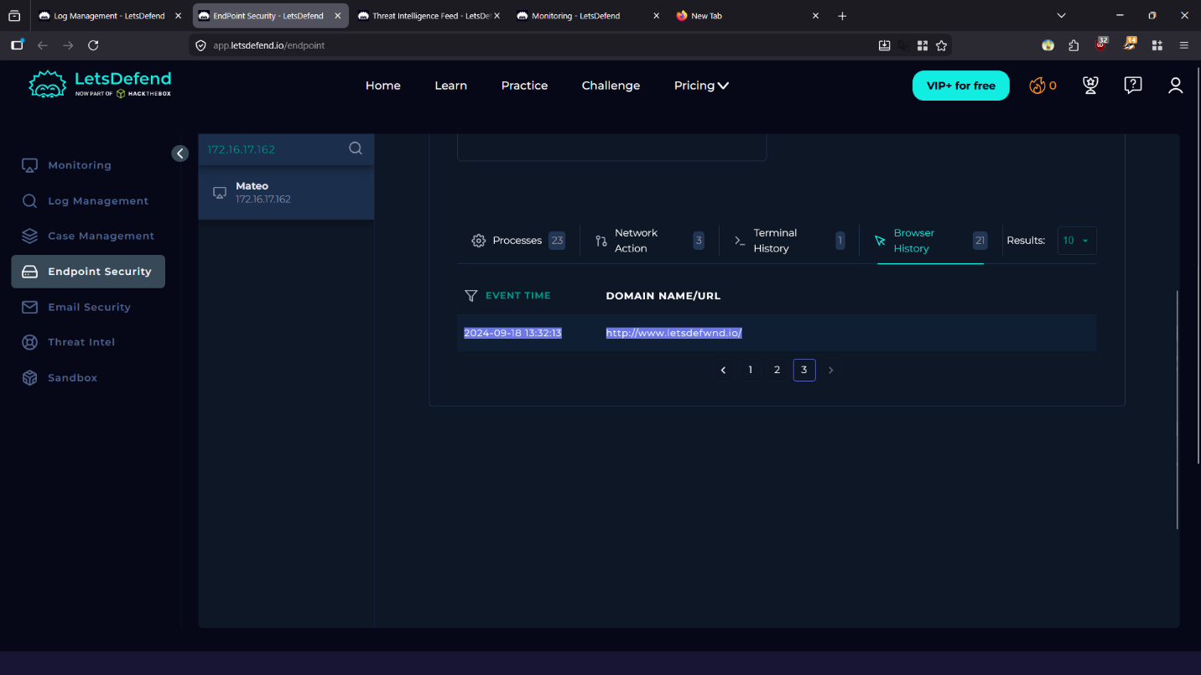
--------------------------------------------------
5. Incident Classification
--------------------------------------------------

Type: Phishing Attack
Vector: Typosquatting Domain + Email
Technique: Credential Harvesting / Possible Malware Delivery

MITRE ATT&CK Mapping:
T1566 - Phishing
T1583.001 - Acquire Infrastructure (Domains)
T1204 - User Execution
T1071.001 - Application Layer Protocol (HTTPS)

--------------------------------------------------
6. Impact Assessment
--------------------------------------------------

[Risk Factors]
- Email bypassed security controls
- User interaction confirmed
- Outbound connection to malicious IP
- Encrypted communication (HTTPS)

[Potential Impact]
- Credential compromise
- Unauthorized access
- Malware infection
- Data exfiltration

Impact Level: Critical

--------------------------------------------------
7. Response Actions
--------------------------------------------------

[Immediate Containment]
- Isolated endpoint: Mateo (172.16.17.162)
- Blocked active network connections

[Credential Security]
- Forced password reset for affected user
- Revoked all active sessions (AD, O365, internal systems)

--------------------------------------------------

[Eradication]
- Removed phishing emails from all inboxes
- Conducted full EDR and antivirus scan on endpoint

--------------------------------------------------

[Prevention / Hardening]
- Blocked domain: letsdefwnd.io
- Blocked IP: 45.33.23.183
- Updated firewall and SWG policies

--------------------------------------------------

[Detection Improvement]
- Enhanced SEG rules:
* Detect newly registered domains (NRDs)
* Detect typosquatting (Levenshtein similarity)

--------------------------------------------------

[Security Awareness]
- Conducted targeted phishing awareness training
- Focus areas:
* Domain verification
* Typosquatting detection
* Safe link handling

--------------------------------------------------
8. Lessons Learned
--------------------------------------------------
- Email filtering requires enhancement
- Need better detection for lookalike domains
- User awareness remains critical defense layer
- Importance of endpoint telemetry correlation

--------------------------------------------------
9. Final Verdict
--------------------------------------------------

True Positive – Confirmed Phishing Compromise

This incident demonstrates a complete phishing attack lifecycle:
- Infrastructure setup
- Email delivery
- User interaction
- External communication

Immediate response actions successfully contained the threat and reduced further risk.

===========================================
END OF REPORT
===========================================

